Guidelines for Completing the Submission:
While filling in the authors' information, the author's ORCID must be correctly entered in the “User Details” field. At the end of the form, in the field related to ORCID, it is necessary to check the option “Send e-mail to request ORCID authorization from contributor” and then save.
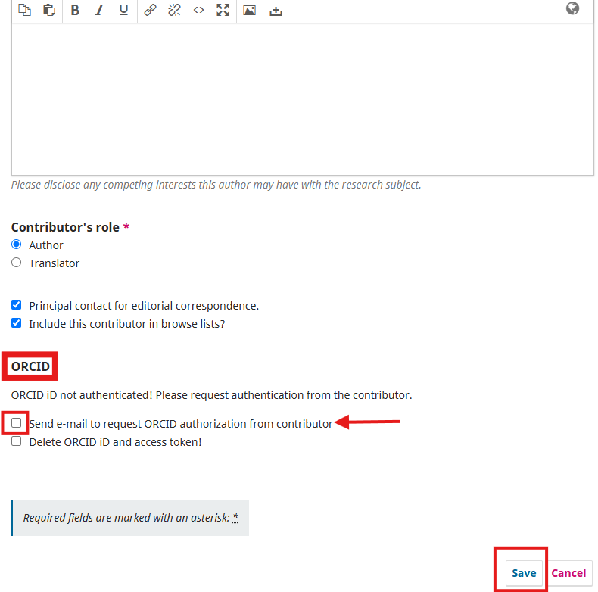
By performing this procedure, the author (or co-author) will receive an email containing a link to validate their ORCID. Since the submission has not yet been completed, the content of the email will be similar to the template shown in the image. The author/co-author must click the link, log in to their ORCID account, and the linking will be carried out automatically, with a message confirming the validation.
After this step, the author responsible for the submission must access the system again to complete the process.
The submission can only be completed after all authors have validated their ORCIDs.
